**Ex.No: 1**

**Date: FUNDAMENTALS OF COMPUTER VISION**

**AIM:**

To know about Fundamentals of Computer vision.

**THEORY:**

Computer vision is a field of study which enables computers to replicate the human visual system. It's a subset of artificial intelligence that collects information from digital images or videos and processes them to define the attributes. Origin of Computer Vision: Computer vision is not a new concept; in fact, it dates back to the 1960s. It all started with an MIT project - “Summer Vision Project” which analysed scenes to identify objects. David Marr, the celebrated neuroscientist, laid down the building blocks of computer vision, taking a cue from the functions of the cerebellum, hippocampus, and cortex of human perception. He has been dubbed the father of computer vision since, and the field has evolved to include much more complicated functionalities.

**Computer Vision Tasks:**

**Image Classifications:**

The Image Classification problem is the task of assigning an input image one label from a fixed set of categories. This is one of the core problems in a CV that, despite its simplicity, has a large variety of practical applications. Moreover, as we will see later, many other seemingly distinct CV tasks (such as object detection, segmentation) can be reduced to image classification.

**Object Localizations:**

This is a sort of intermediate task in between the other two ILSRVC tasks, image classification, and object detection. In image classification, you have to assign a single label to an image corresponding to the “main” object (eventually, the image can contain multiple objects). The classification + localization requires also localizing a single instance of this object, even if the image contains multiple instances of it. This task is also called “single-instance localization”.

**Object Detection:**

Object detection is the process of finding instances of real-world objects such as faces, bicycles, and buildings in images or videos. Object detection algorithms typically use extracted features and learning algorithms to recognize instances of an object category. It is commonly used in applications such as image retrieval, security, surveillance, and automated vehicle parking systems.

**Image Segmentation:**

There are two kinds of segmentation tasks in a CV: Semantic Segmentation & Instance Segmentation. The difference between them is on Instance segmentation and semantic segmentation Some other tasks in computer vision

● Optical character recognition (OCR)

● Machine inspection

● Retail (Eg. automated checkouts)

● 3D model building (photogrammetry)

● Medical imaging

● Automotive safety

● Match move (Eg. merging CGI with live actors in movies)

● Motion capture (mocap)

● Surveillance

● Fingerprint recognition and biometrics

**Computer Vision Challenges:**

Computer vision might have emerged as one of the top fields of machine learning, but there are still several obstacles in its way to becoming a leading technology. Human vision is a complicated and highly effective system that is difficult to replicate through technology. However, that’s not to say that computer vision will not improve in the future.

**Applications of Computer Vision:**

1. Retail: Customer Behaviour Tracking.

2. Agriculture: Detection of Wheat Rust.

3. Public Health: Image Segmentation of Scans.

4. Automotive Industry: Object Recognition and Classification in Traffic.

5. Fitness: Human Pose Estimation.

6. Medical Imaging: Computer vision helps in MRI reconstruction, automatic pathology, diagnosis, machine-aided surgeries, and more.

7. AR/VR: Object occlusion (dense depth estimation), outside-in tracking, inside-out tracking for virtual and augmented reality.

8. Smartphones: All the photo filters (including animation filters on social media), QR code scanners, panorama construction, Computational photography, face detectors, image detectors (Google Lens, Night Sight) that you use are computer vision applications.

9. Internet: Image search, geolocalisation, image captioning, ariel imaging for maps, video categorization, and more.

**RESULT:**

The Fundamentals of Computer Vision are given above in detail.

**Ex.No: 2**

**Date: INTRODUCTION TO OPENCV**

**AIM:**

To write a program for Introduction to OpenCV in python.

**THEORY:**

OpenCV is one of the most popular computer vision libraries. If you want to start your journey in the field of computer vision, then a thorough understanding of the concepts

of OpenCV is of paramount importance. In this exercise, we will see the most basic and important concepts of OpenCV in an intuitive manner.

**Topics:**

1. Reading an image
2. Extracting the RGB values of a pixel
3. Extracting the Region of Interest (ROI)
4. Resizing the Image

**Image:**

An Image is a spatial representation of a two dimensional or three-dimensional scene. It is an array or a matrix pixel (picture elements) arranged in columns and rows. ... Digital Image is composed of picture elements, image elements, and pixels. A Pixel is most widely used to denote the elements of a Digital Image.

**Installation of the opencv-python library:**

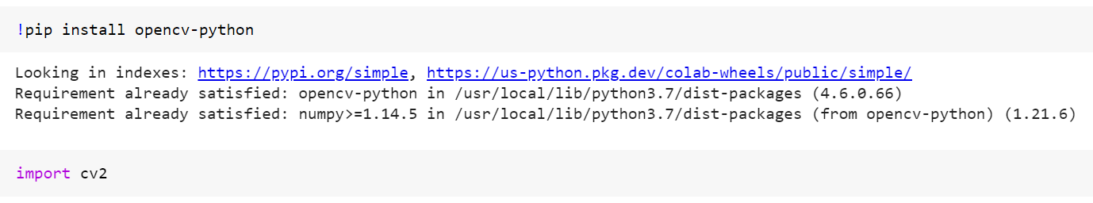

**Reading and showing an image:**

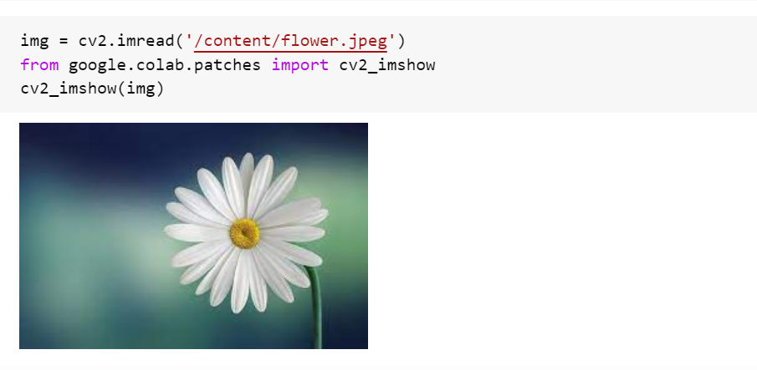

**Extracting the height, width and channel of the image:**

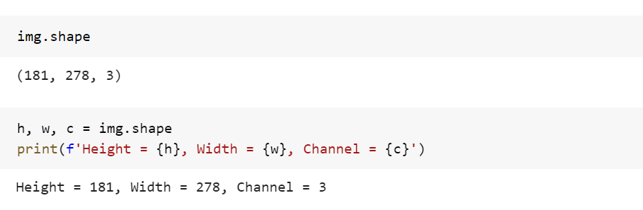

**Extracting the RGB values of a pixel:**

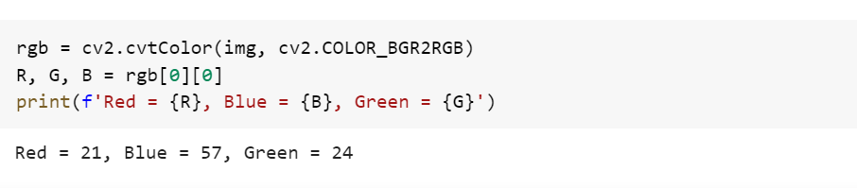

**Extracting the Region of Interest (ROI):**

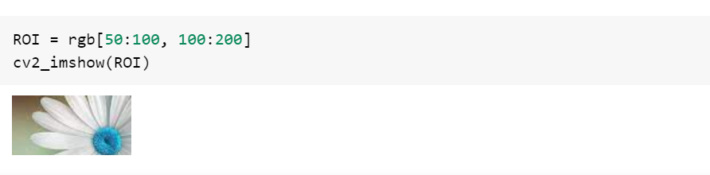

**RESULT:**

The Introduction to OpenCV has been explained above.

**Ex.No: 3**

**Date: READ, WRITE, SHOW IMAGES IN OPENCV**

**AIM:**

To write a program to Read, Write and Show Images in OpenCV.

**THEORY:**

Reading, displaying, and writing images are basic to image processing and computer vision. OpenCV, the largest computer vision library in the world has these three built-in functions,

1. **imread()** helps us read an image
2. **imwrite()** writes an image into the file directory
3. **imshow()** displays an image in a window

**PROCEDURE:**

**Step 1:** Import the required library.

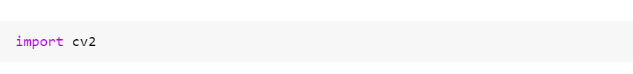

**Step 2:** Reading an image.

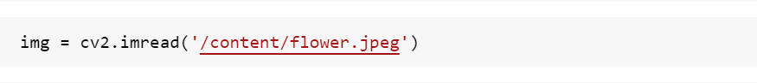

**Step 3:** Writing the image.

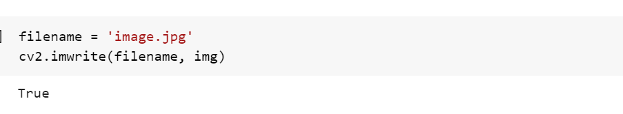

**Step 4:** Showing the image using **imshow().**

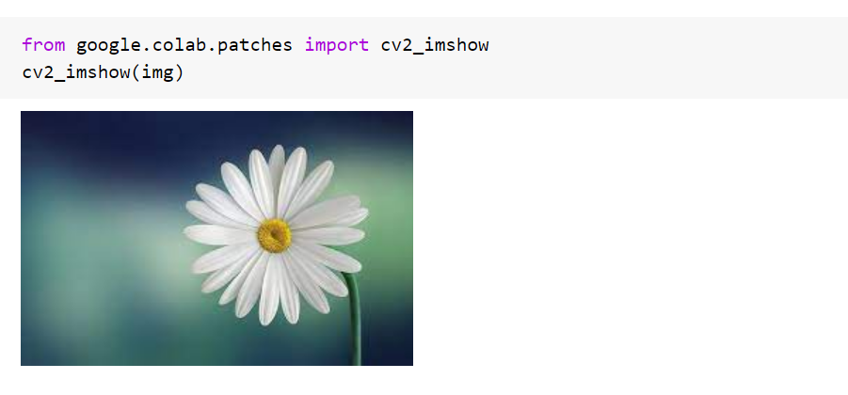

**RESULT:**

The read, write and show images are done using OpenCV in python.

**Ex.No: 4**

**Date: IMAGE PROCESSING USING OPENCV**

**AIM:**

To write a program for image processing tasks such as image shrinking, enlarging, resizing, blurring and making borders using OpenCV in python.

**THEORY:**

Image Processing is a field of knowledge that falls in Computer Vision. The premises of machine learning were first laid down by computer vision theory, applying a whole set of techniques to process and analyse imagery data to extract valuable information that computers and machines may use for a wide range of applications. Image processing is a prior step in computer vision, where the goal is to convert an image into a form suitable for further analysis. Examples of operations such as **image** **shrinking, enlarging, resizing, blurring, making borders** are used in most computer vision applications like computational photography or even face recognition.

**PROCEDURE:**

**Step 1:** Import the required libraries.

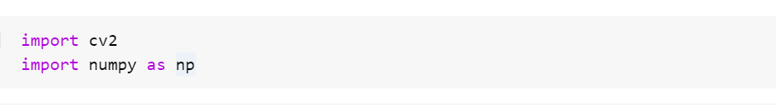

**Step 2:** Read the image and show the image.

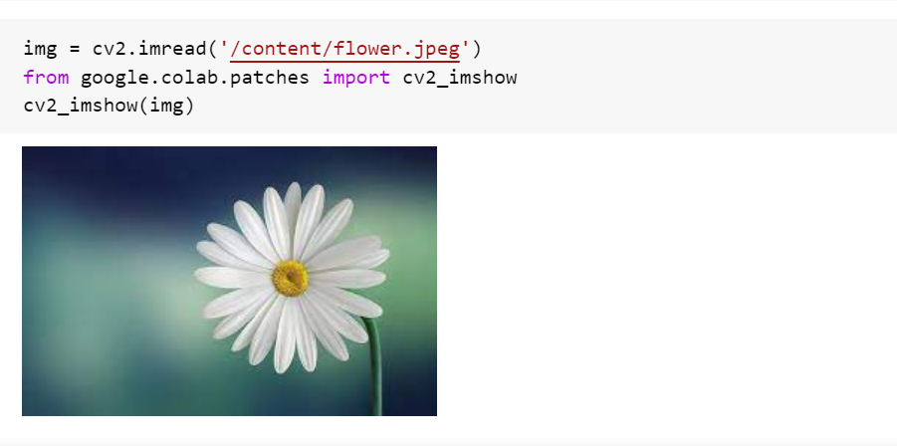

**Step 3:** Resizing the image.

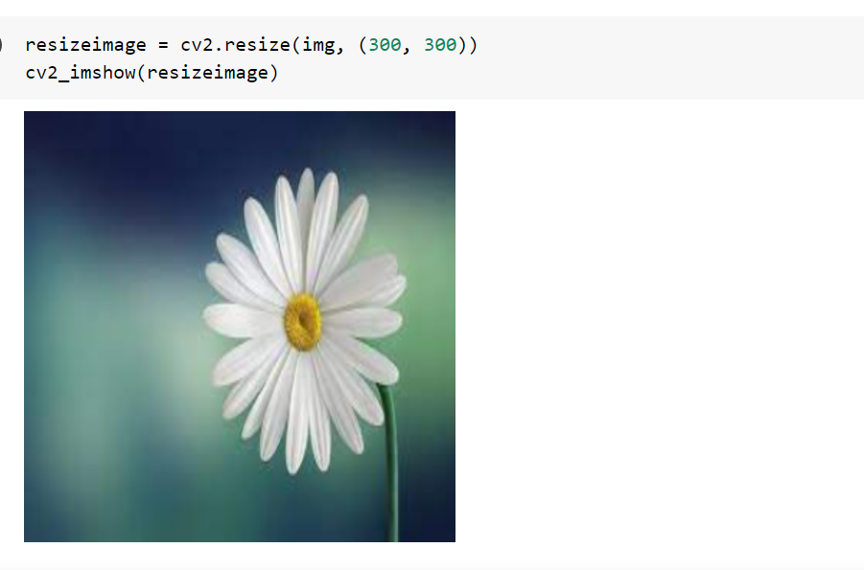

**Step 4:** Shrinking an image

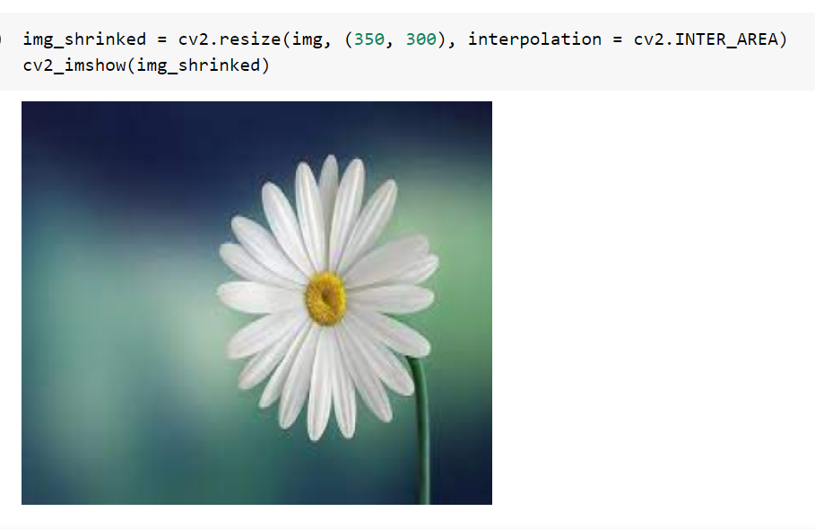

**Step 5:** Enlarging the image.

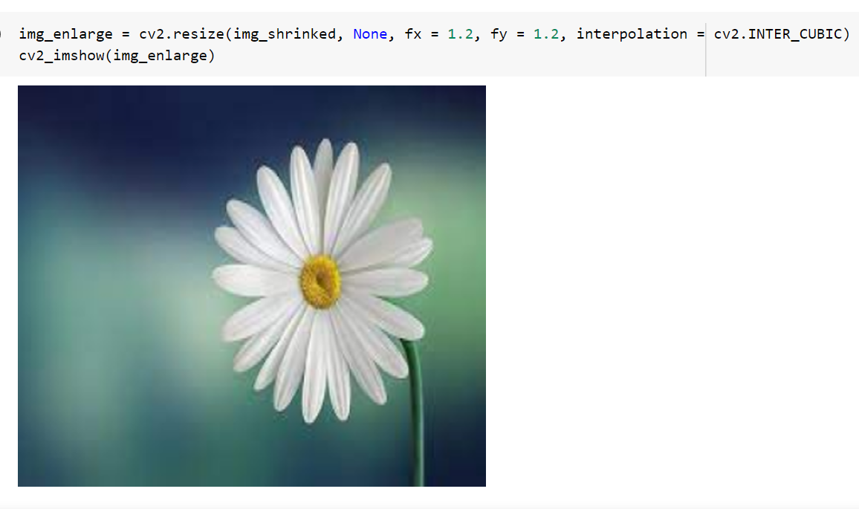

**Step 6:** Blurring the image using **GaussianBlur** method.

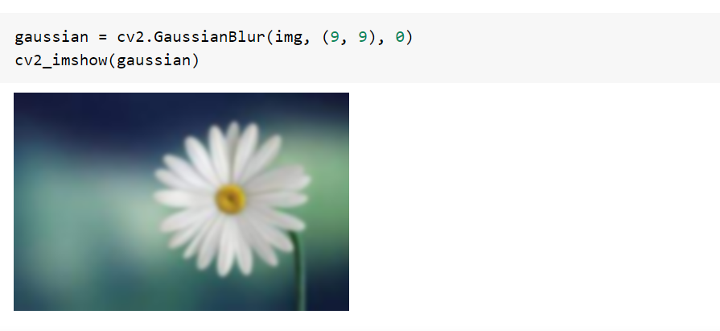

**Step 7**: Blurring the image using **medianBlur** method.

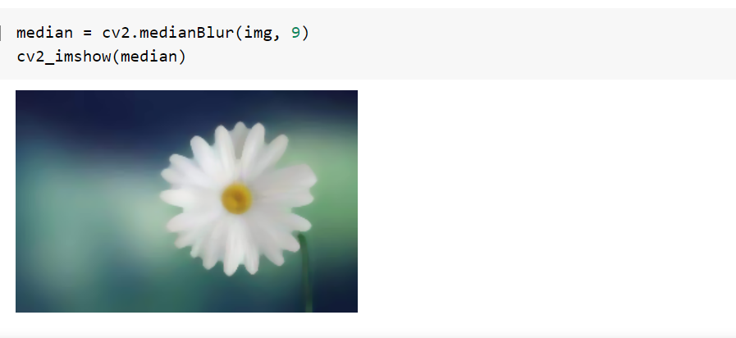

**Step 8:** Blurring the image using **bilateralFilter** method.

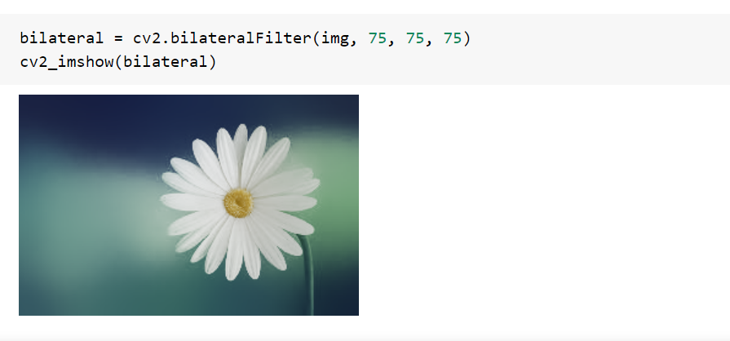

**Step 9:** Making border for image using **border constant** method.

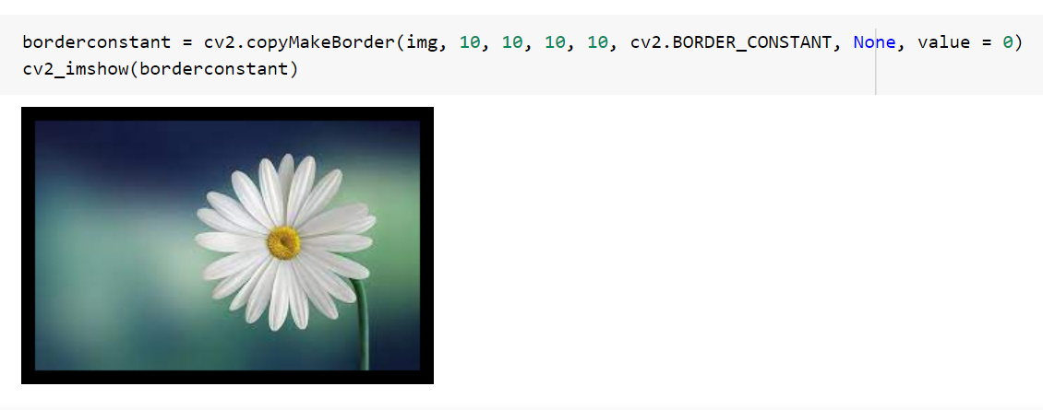

**Step 10:** Making border for image using **border reflect** method.

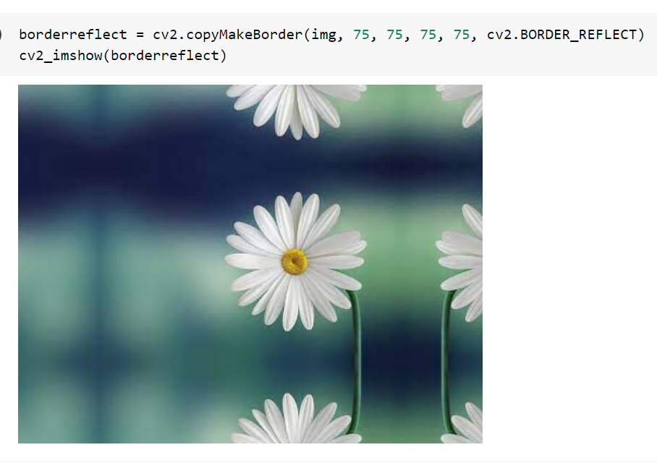

**RESULT:**

The image processing tasks are done successfully on the given image.

**Ex.No: 5**

**Date: IMAGE TRANSFORMATION I**

**AIM:**

To write a program to perform image transformation (Affine Transformation) using OpenCV in python.

**THEORY:**

In image processing, image transformation can be defined as having control on its dimensional points to edit the images by moving them into three dimensional or two-dimensional space. Euclidean transformation is a type of geometric transformation that causes changes in the dimensions and angles without causing the change in the basic structure-like area. Image Transformation works based on euclidean transformation, where the image can look shifted or rotated, but the structure of pixels and matrix will remain the same.

Roughly we can divide image transformation into two sections:

* Affine transformation
* Perspective transformation

**Affine Transformation:**

In Affine transformation, all parallel lines in the original image will still be parallel in the output image. To find the transformation matrix, we need three points from input image and their corresponding locations in the output image. Then **cv2.getAffineTransform** will create a 2×3 matrix which is to be passed to **cv2.warpAffine**.

**PROCEDURE:**

**Step 1:** Import the required libraries.

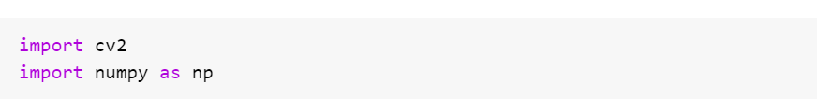

**Step 2:** Read the image and show the image.

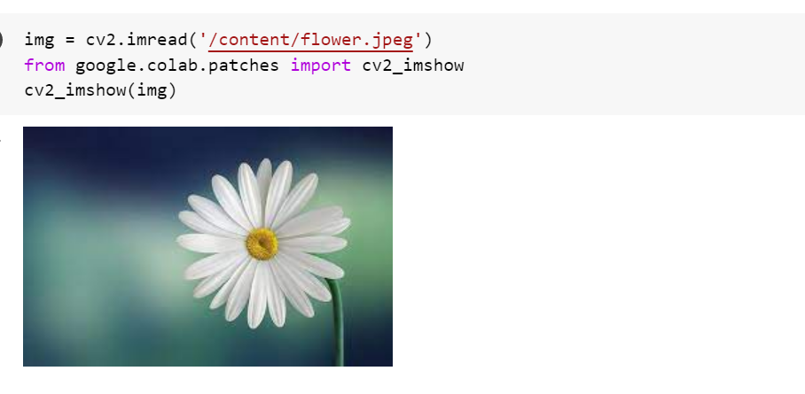

**Step 3: cv2.warpAffine** function is used to implement simple remapping routines. An affine transformation is transformation which preserves lines and parallelism.

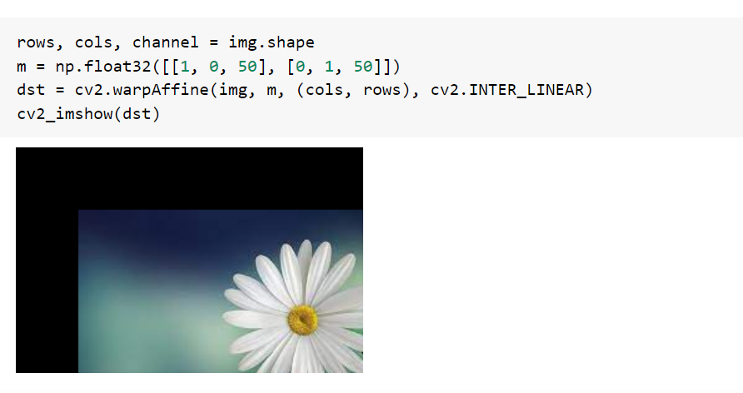

**Step 4: cv2.getRotationMatrix2D** function is used to make the transformation matrix m which will be used for rotating an image. These transformation matrix are taken by **warpAffine** function as parameter and the rotated image will be returned.

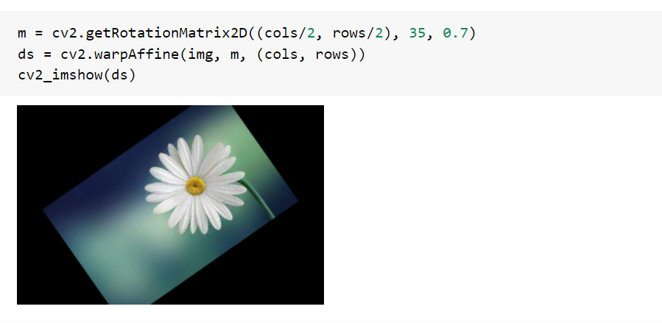

**Step 5:** In Affine transformation, all parallel lines in the original image will still be parallel in the output image. To find the transformation matrix, we need three points from input image and their corresponding locations in the output image. Then **cv2.getAffineTransform** will create a 2×3 matrix which is to be passed to **cv2.warpAffine**.

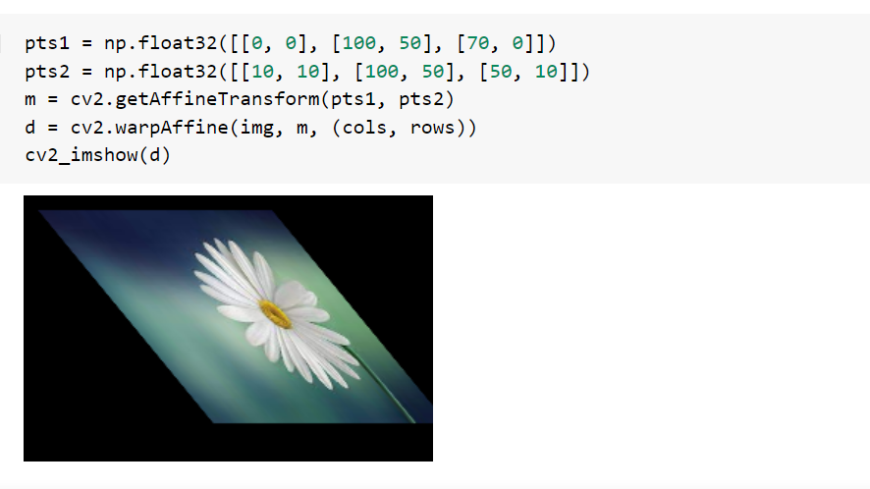

**RESULT:**

The image transformations (Affine Transformation) are done on the given image using OpenCV in python.

**Ex.No: 6**

**Date: IMAGE TRANSFORMATION II**

**AIM:**

To write a program to perform image transformation (Perspective Transformation) using OpenCV in python.

**THEORY:**

In image processing, image transformation can be defined as having control on its dimensional points to edit the images by moving them into three dimensional or two-dimensional space. Euclidean transformation is a type of geometric transformation that causes changes in the dimensions and angles without causing the change in the basic structure-like area. Image Transformation works based on euclidean transformation, where the image can look shifted or rotated, but the structure of pixels and matrix will remain the same.

Roughly we can divide image transformation into two sections:

* Affine transformation
* Perspective transformation

**Perspective Transformation:**

In Perspective Transformation, we can change the perspective of a given image or video for getting better insights into the required information. In Perspective Transformation, we need to provide the points on the image from which want to gather information by changing the perspective. We also need to provide the points inside which we want to display our image. Then, we get the perspective transform from the two given sets of points and wrap it with the original image.

**PROCEDURE:**

**Step 1:** Import the required libraries.

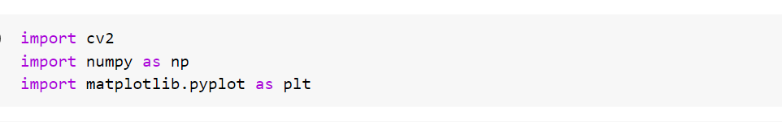

**Step 2:** Read the image and show the image.



**Step 3:** We use **cv2.getPerspectiveTransform** and then **cv2.warpPerspective**.

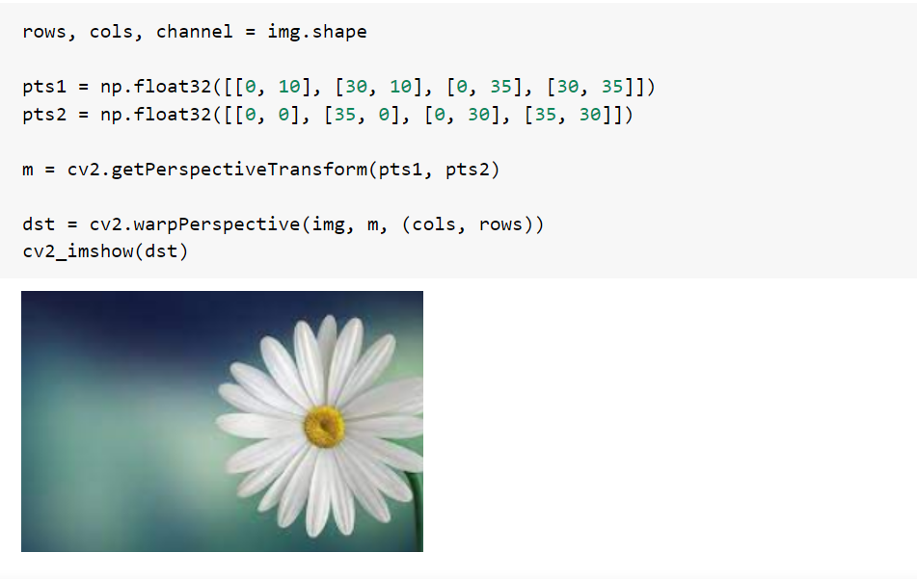

**Step 4:** The most basic morphological operations are two:**Erosion and Dilation**   
**Basics of Erosion:**

* Erodes away the boundaries of the foreground object
* Used to diminish the features of an image.

**Erosion:**

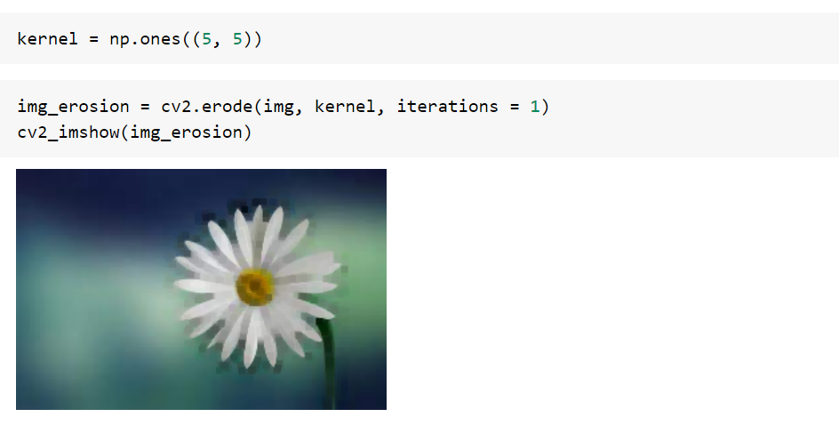

**Basics of dilation:**

* Increases the object area
* Used to accentuate features

**Dilation:**

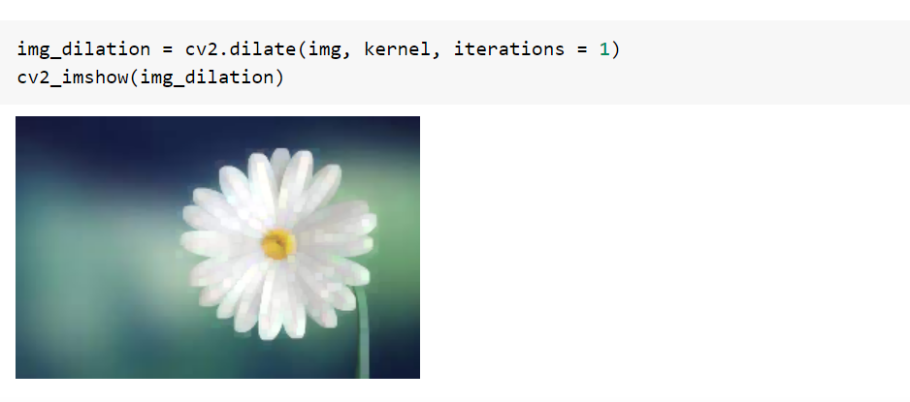

**Step 5:** Histogram is considered as a graph or plot which is related to frequency of pixels in an Gray Scale Image with pixel values (ranging from 0 to 255).

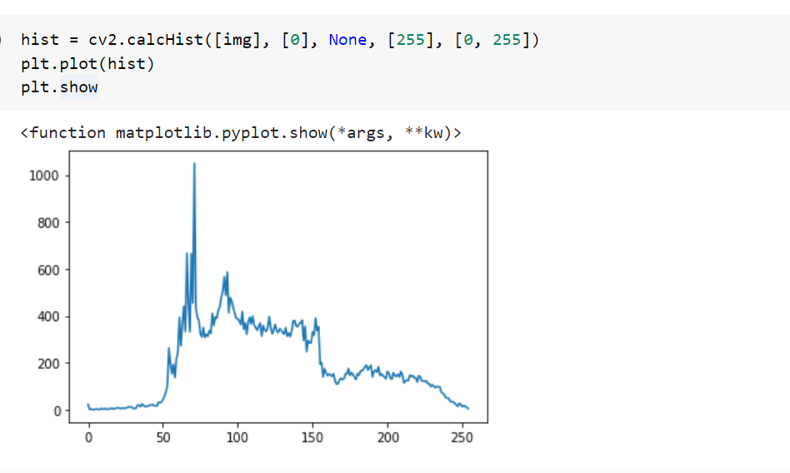

**Step 6:** **Threshold** is a technique in OpenCV, which is the assignment of pixel values in relation to the threshold value provided. In thresholding, each pixel value is compared with the threshold value. If the pixel value is smaller than the threshold, it is set to 0, otherwise, it is set to a maximum value (generally 255).

* **cv2.THRESH_BINARY:** If pixel intensity is greater than the set threshold, value set to 255, else set to 0 (black).
* **cv2.THRESH_BINARY_INV:** Inverted or Opposite case of cv2.THRESH_BINARY.
* **cv.THRESH_TRUNC:** If pixel intensity value is greater than threshold, it is truncated to the threshold. The pixel values are set to be the same as the threshold. All other values remain the same.
* **cv.THRESH_TOZERO:** Pixel intensity is set to 0, for all the pixels intensity, less than the threshold value.
* **cv.THRESH_TOZERO_INV:** Inverted or Opposite case of cv2.THRESH_TOZERO.

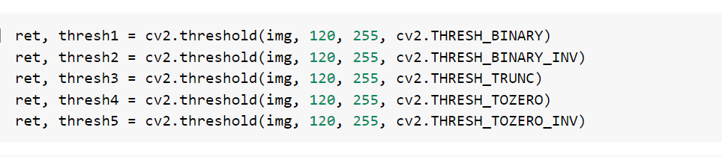

**cv2.THRESH_BINARY:**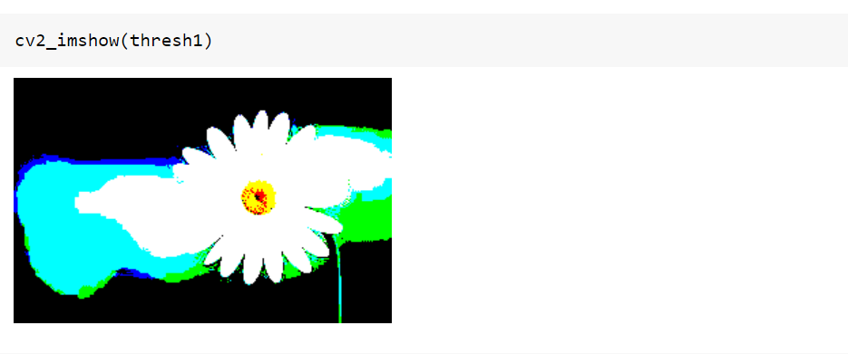

**cv2.THRESH_BINARY_INV:**

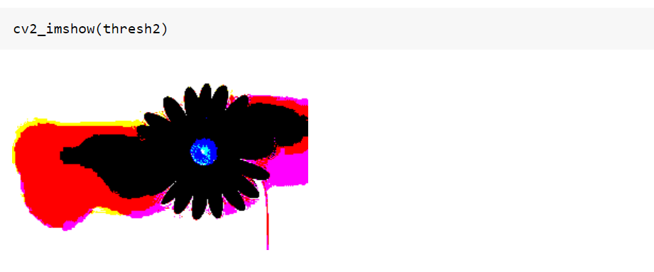

**cv.THRESH_TRUNC:**

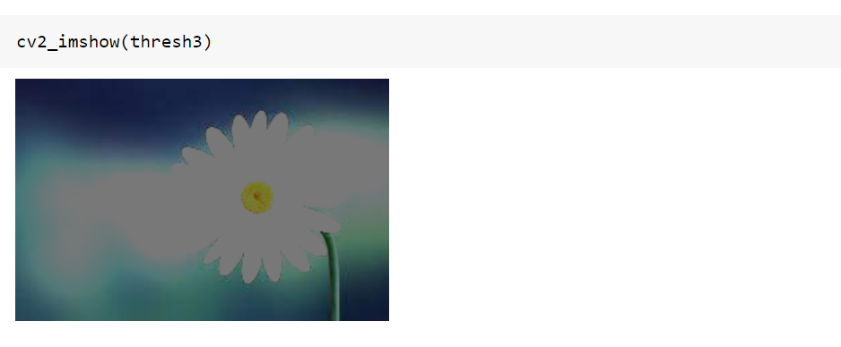

**cv.THRESH_TOZERO:**

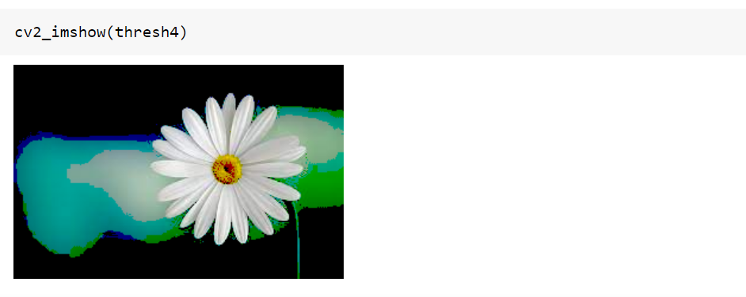

**cv.THRESH_TOZERO_INV:**

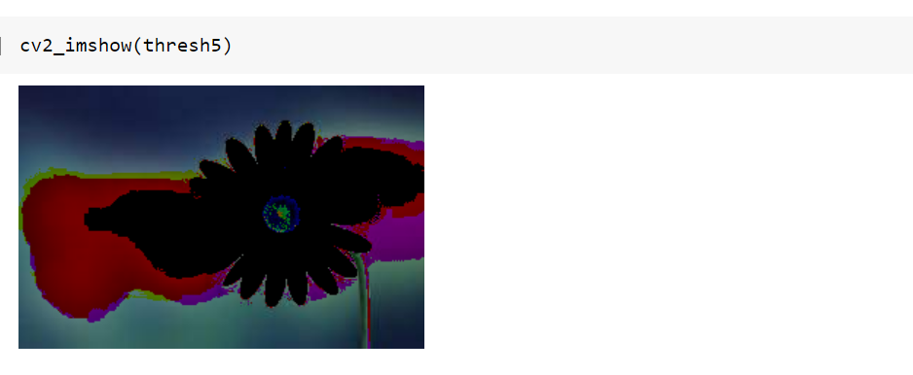

**RESULT:**

The image transformations like Perspective Transformation, Erosion, Dilation and Threshold are done on the given image using OpenCV in python.

**Ex.No: 7**

**Date: FEATURE DETECTION AND DESCRIPTION**

**AIM:**

To write a program for Feature Detection and Description in OpenCV.

**THEORY:**

Feature detection is the process of checking the important features of the image. In this case, features of the image can be edges, corners, ridges, and blobs in the images.

**Method 1: Haris corner detection**

Haris corner detection is a method in which we can detect the corners of the image by sliding a slider box all over the image by finding the corners and it will apply a threshold and the corners will be marked in the image. This algorithm is mainly used to detect the corners of the image.

**Method 2: Shi-Tomasi corner detection**

Shi and Tomasi came up with a different corner detection algorithm which is mostly similar to the Haris corner detection algorithm in which the only difference will be the kernel value in which we can find only the n strongest corners of the image. This can greatly help while we need only the limited and very important features of the image.

**Method 3: SIFT (Scale-Invariant Feature Transform)**

While Haris and Shi-Tomasi are the algorithms to detect the corners of the image. SIFT is one of the important algorithms that detect objects irrelevant to the scale and rotation of the image and the reference. This helps a lot while we are comparing the real-world objects to an image though it is independent of the angle and scale of the image. This method will return the key points of the images which we need to mark in the image.

**Method 4: FAST algorithm for corner detection**

SURF is fast when compared to SIFT but not as fast to use with real-time devices like mobile phones and surveillance cameras. So FAST algorithm was introduced with a very fast computing time. However FAST gives us only the key points and we may need to compute descriptors with other algorithms like SIFT and SURF. With a Fast algorithm, we can detect corners and also blobs.

**PROCEDURE:**

**Step 1:** Import the required libraries. Then read the image and show the image.

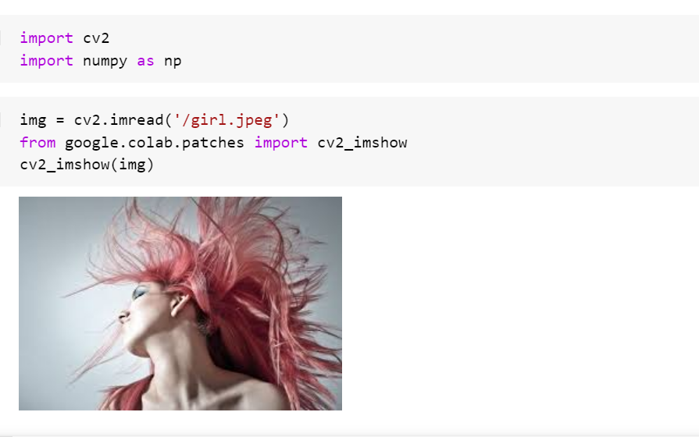

**Step 2:** Haris Corner Detection

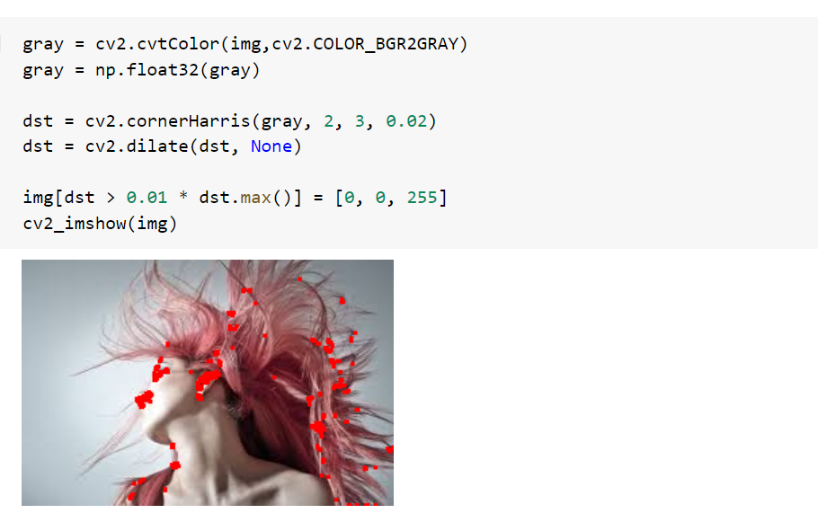

**Step 3:** Shi-Tomasi Corner Detection

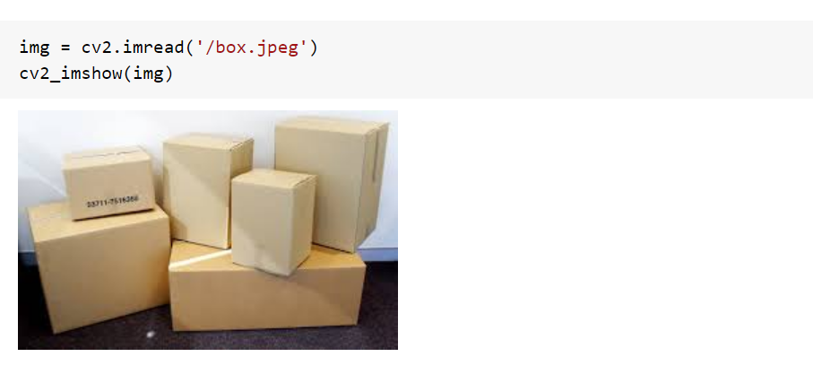

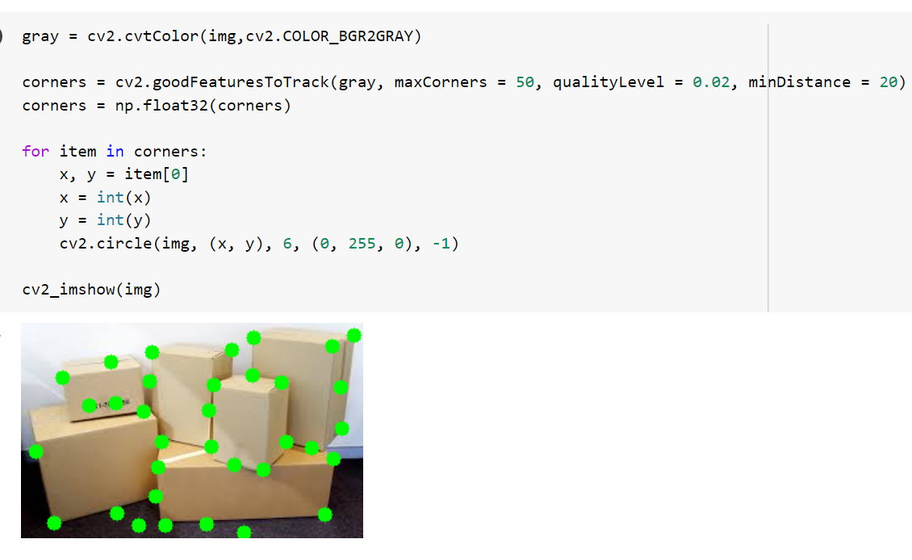

**Step 4:** SIFT (Scale-Invariant Feature Transform)

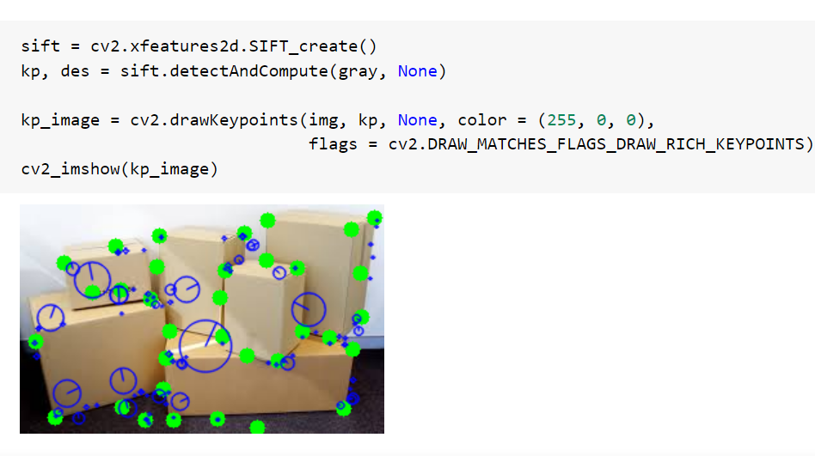

**Step 5:** FAST Algorithm for Corner Detection

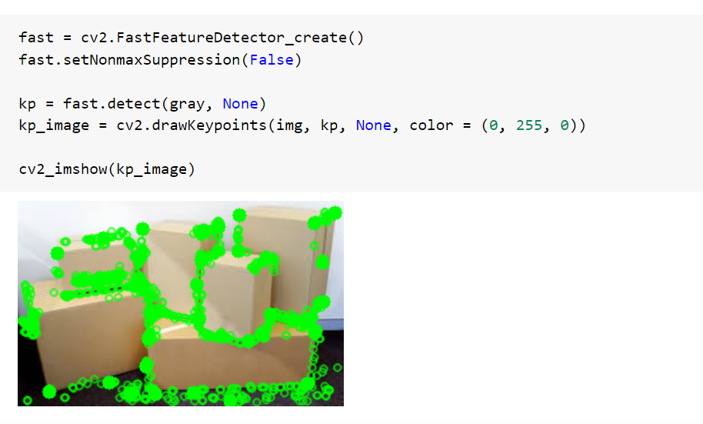

**RESULT:**

Feature Detection of the images was successfully done using OpenCV.

**Ex.No: 8**

**Date: FEATURE MATCHING AND MODEL FITTING**

**AIM:**

To write a program for Feature Matching and Model Fitting using OpenCV in python.

**THEORY:**

Mathematical representations of key areas in an image are the features. Features are the vector representations of the visual content from an image so that we can perform mathematical operations on them. Features from an image plays an important role in computer vision for variety of applications including object detection, motion estimation, segmentation, image alignment and a lot more.

* Harris Corner Detection
* Shi-Tomasi Corner Detection
* SIFT (Scale-Invariant Feature Transform)
* SURF (Speeder-Up Robust Features)
* FAST algorithm for corner detection
* ORB (Oriented FAST and Rotated Brief)

**PROCEDURE:**

**Step 1:** To read the image.

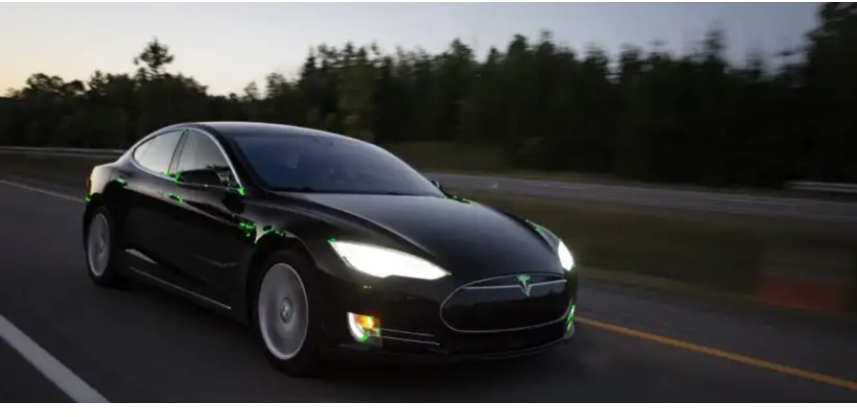

**Step 2:** SURF (Speeded-Up Robust Features)

Even though SIFT works well it performs intensive operations which are time consuming. SURF was introduced to have all the advantages of SIFT with reduced processing time.

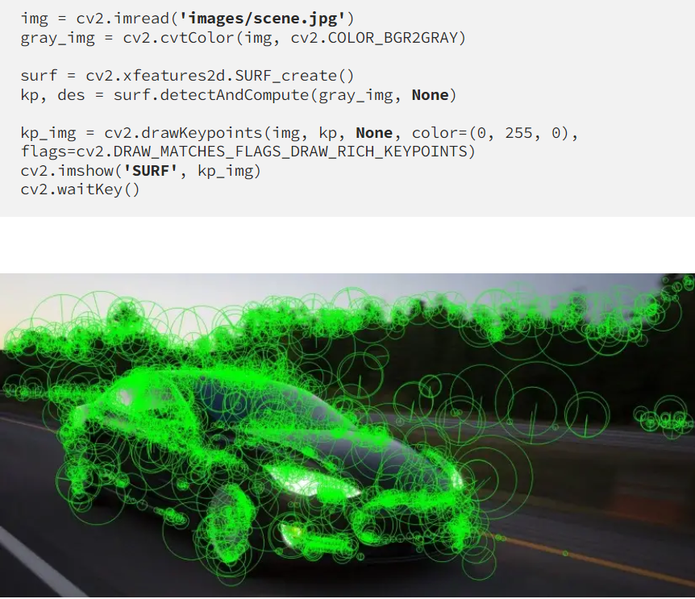

**Step 3:** ORB (Oriented FAST and Rotated Brief)

ORB is an efficient open-source alternative to SIFT and SURF. Even though it computes less key points when compared to SIFT and SURF yet they are effective. It uses FAST and BRIEF techniques to detect the key points and compute the image descriptors respectively.

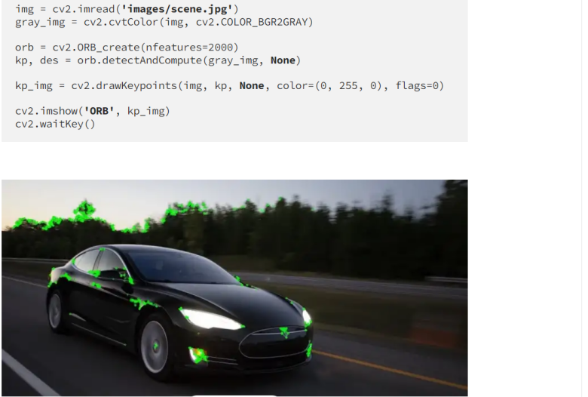

**Step 4: Feature matching**

Feature matching between images in OpenCV can be done with Brute-Force matcher or FLANN based matcher.

**Brute-Force (BF) Matcher:** BF Matcher matches the descriptor of a feature from one image with all other features of another image and returns the match based on the distance. It is slow since it checks match with all the features.

## 

## 

**RESULT:**

The feature matching and model fitting using OpenCV was executed successfully.

**Ex.No: 9**

**Date: COLOUR FUNDAMENTALS**

**AIM:**

To write a program for colour fundamentals using OpenCV in python.

**THEORY:**

**HSV (Hue, Saturation, Value):**

Just like the most common colour spaces we use to represent an image like RGB and BGR, HSV too is a colour space in which H denotes hue, S denotes Saturation and V denotes value.

**Hue:**

Hues are the three primary colours (red, blue, and yellow) and the three secondary colours (orange, green, and violet) that appear in the colour wheel or colour circle. When you refer to hue, you are referring to pure colour, or the visible spectrum of basic colours that can be seen in a rainbow.

**Saturation:**

Saturation gives the purity of a colour. A pure colour has no gray mixed in it. Greater the amount of grey mixed in a colour, lesser the saturation. The saturation value is usually measured from 0 to 100% but in OpenCV the scale for saturation is from 0 to 255.

**Value:**

This is a measure of the brightness of a colour. When the brightness value is maximum, the colour turns white and when the brightness value is minimum, the colour turns black. This is usually measured from 0 to 100% but in OpenCV the scale for value is from 0 to 255.

**PROCEDURE:**

**Step 1:** Import the required libraries.



**Step 2:** Read the image and show the image.

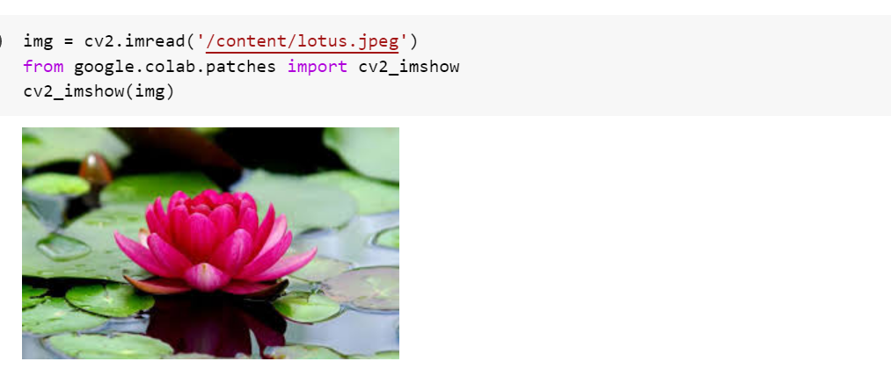

**Step 3:** Convert the image to HSV format.

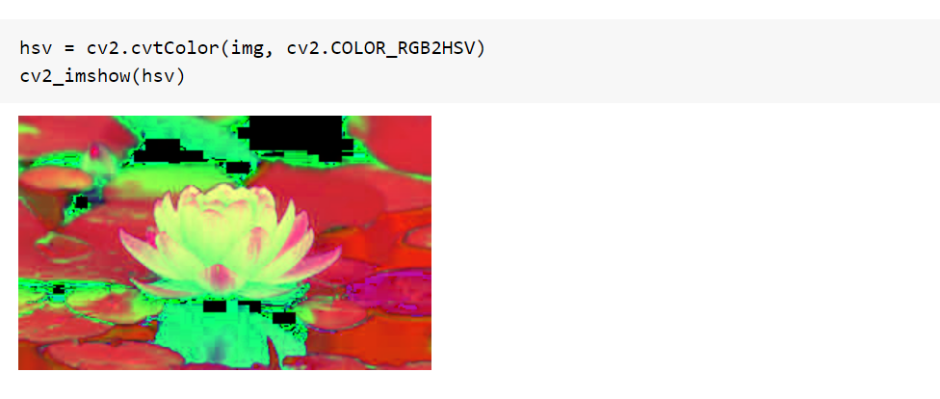

**Step 4:** Setting the green upper and lower bounds to filter the green part of the image.

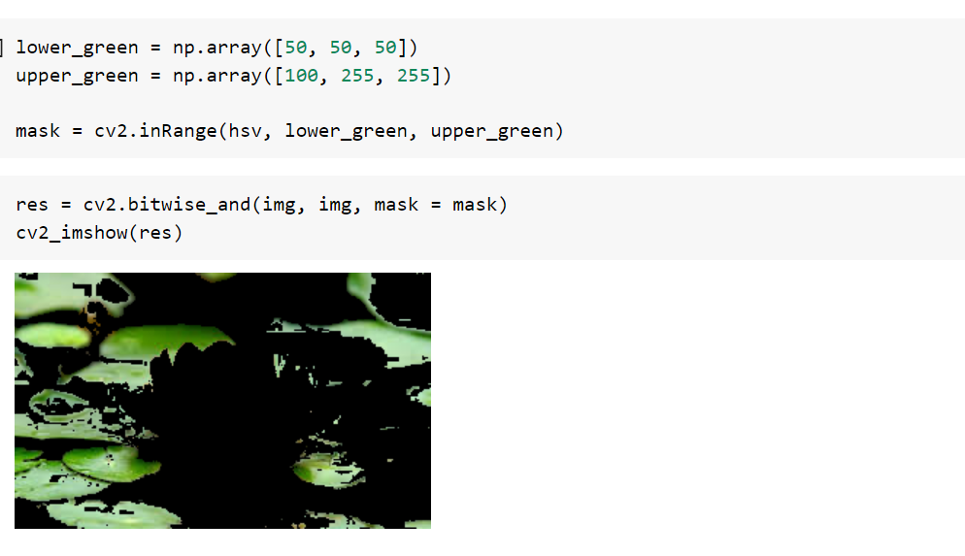

**Step 5:** Create the mask image using **bitwise_and** function.



**Step 6:** Setting the red upper and lower bounds to filter the red part of the image

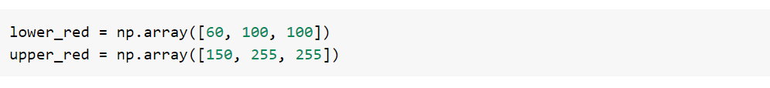

**Step 7:** Create the masked image for red upper and lower bounds.

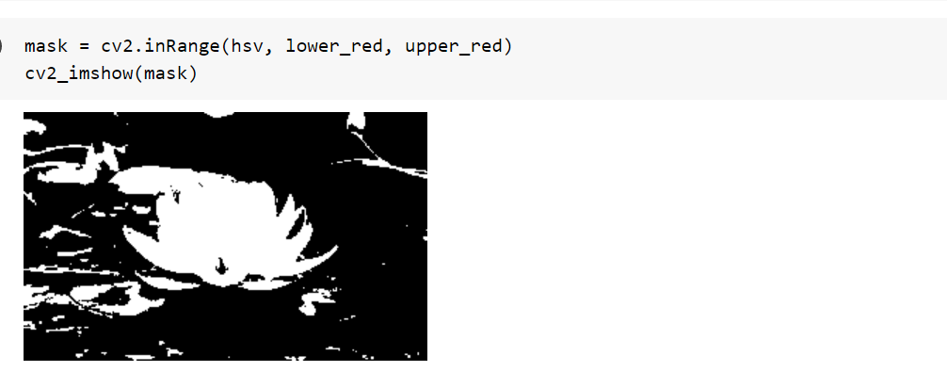

**Step 8:** Create the inverse of the above image using **bitwise_not** function.

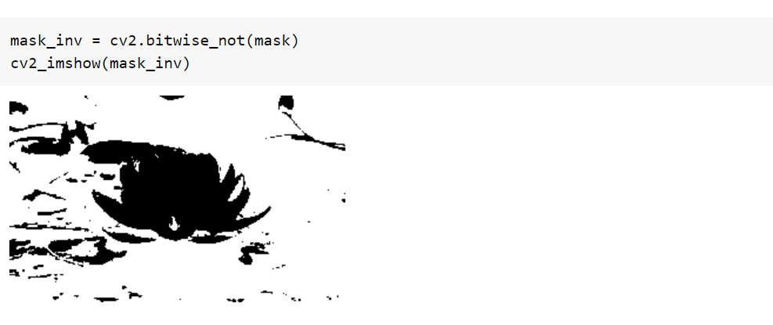

**Step 9:** Create the mask image using **bitwise_and** function. Filter only the red colour from the original image using the mask (foreground).

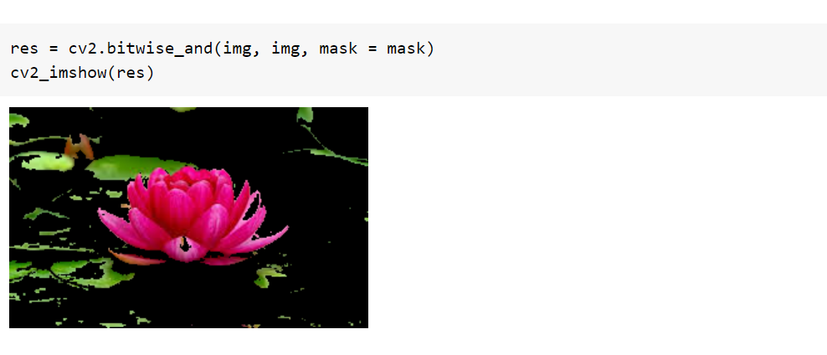

**Step 10:** Obtain the grayscale image of the original image. Filter the regions containing colours other than red from the grayscale image (background).

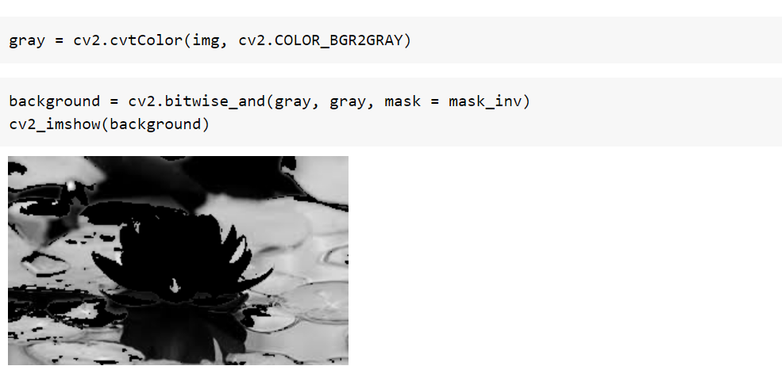

**Step 11:** Stack the image and convert the one channeled grayscale background to a three channeled image.

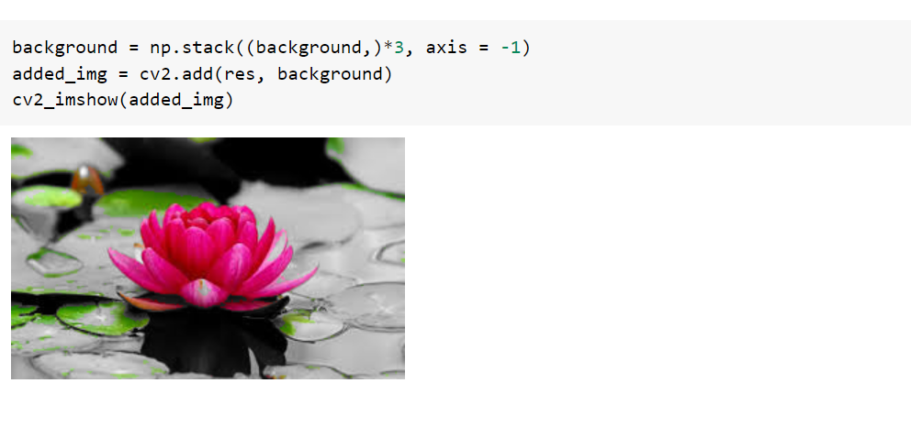

**RESULT:**

The above program for colour fundamentals was executed successfully.

**Ex.No: 10**

**Date: CLUSTERING AND CLASSIFICATION**

**AIM:**

To write a program for clustering and classification using OpenCV in python.

**THEORY:**

Clustering is the task of dividing the population or data points into a number of groups such that the data points in the same group are more similar to other data points in the same group than those in other groups. In simple words, the aim is to segregate groups with similar traits and assign them into clusters. Image classification is the process of categorizing and labelling groups of pixels or vectors within an image based on specific rules. The categorization law can be devised using one or more spectral or textural characteristics. Two general methods of classification are 'supervised' and 'unsupervised'.

**PROCEDURE:**

**Step 1:** Import the required libraries.

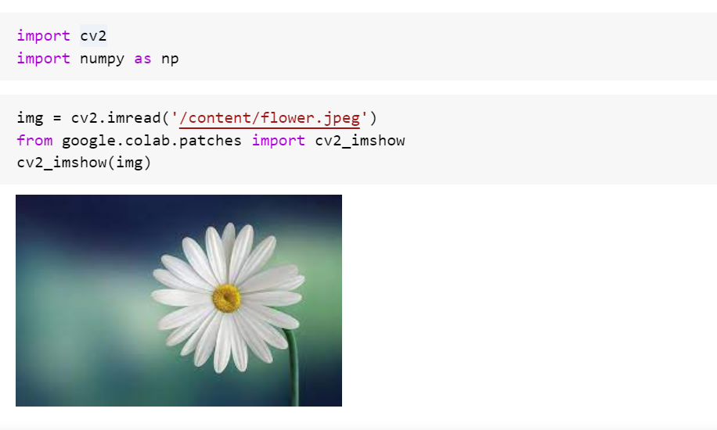

**Step 2:** Read the image and show the image.



**Step 3:** We are going to use the **cv2.kmeans()** function, which takes a 2D array as input, and since our original image is 3D (width, height, and depth of 3 RGB values), we need to flatten the height and width into a single vector of pixels (3 RGB values).

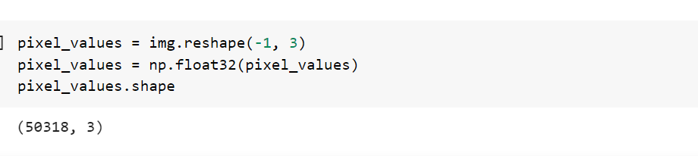

**Step 4:** Define stopping criteria and number of clusters (k). **cv2.KMEANS_RANDOM_CENTERS** just indicates OpenCV to randomly assign the values of the clusters initially.

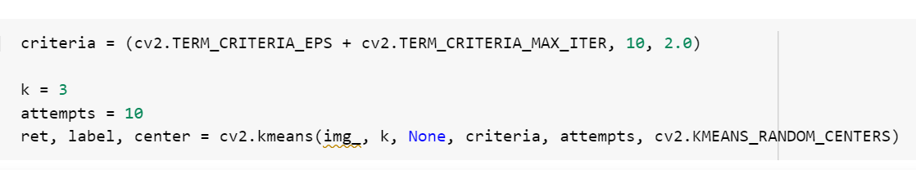

**Step 5:** Convert the center to 8-bit values and flatten the labels array. Reshape back to the original image dimension.

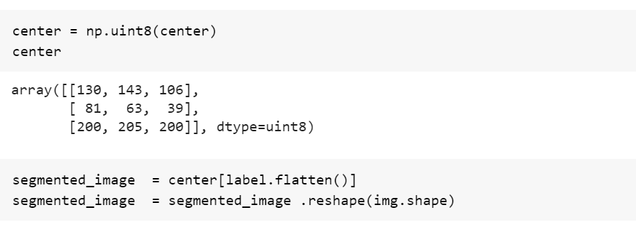

**Step 6:** Show the final output of the image.

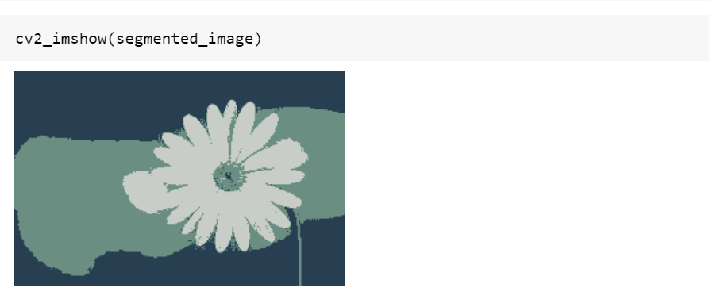

**RESULT:**

The clustering and classification of the image is done using OpenCV.

**Ex.No: 11 DIMENSIONAL REDUCTION AND**

**Date: SPARSE REPRESENTATION**

**AIM:**

To write a code for dimensionality reduction and sparse representation in OpenCV.

**THEORY:**

This is where dimensionality reduction algorithms come into play. Dimensionality reduction is the process of reducing the number of random variables under consideration, by obtaining a set of principal variables. Dimensionality reduction may be both linear and non-linear, depending upon the method used. The prime linear method, called Principal Component Analysis, or PCA, is discussed below. An intuitive example of dimensionality reduction can be discussed through a simple email classification problem, where we need to classify whether the e-mail is spam or not. This can involve a large number of features, such as whether or not the e-mail has a generic title, the content of the e-mail, whether the e-mail uses a template, etc.

**PROCEDURE:**

**Step 1:** Import the required libraries.



**Step 2:** Read the image and show the image.



**Step 3:** Dimensionality Reduction with Principal Component Analysis.

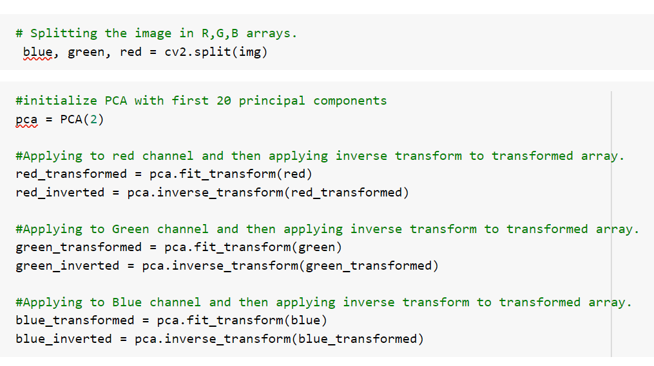

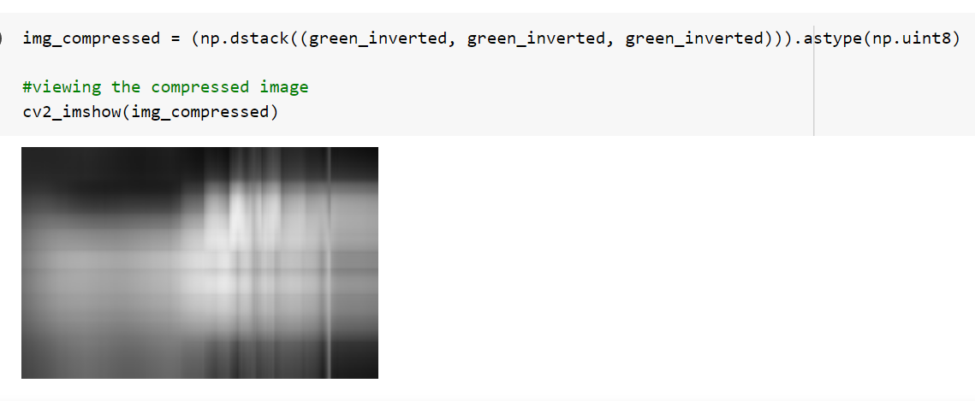

**Step 4:** Singular Value Decomposition

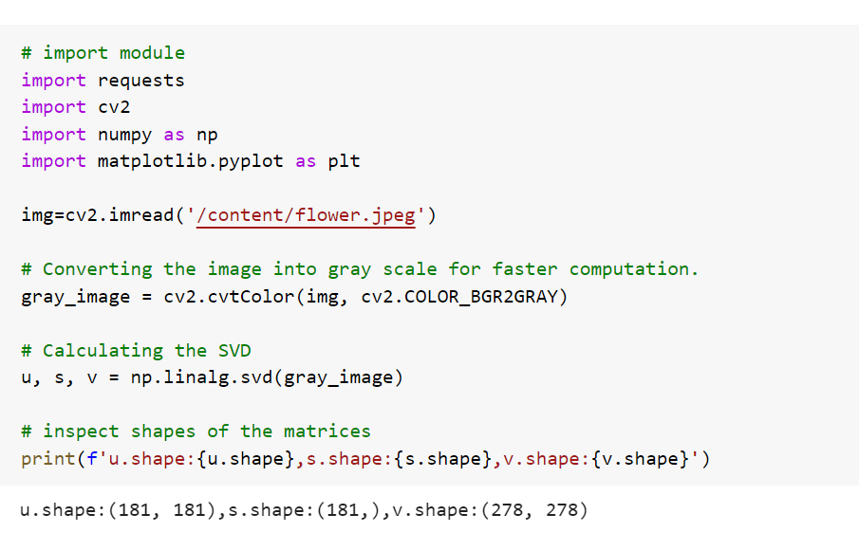

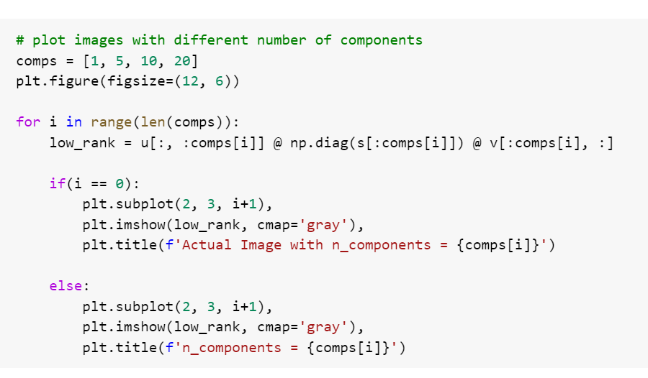

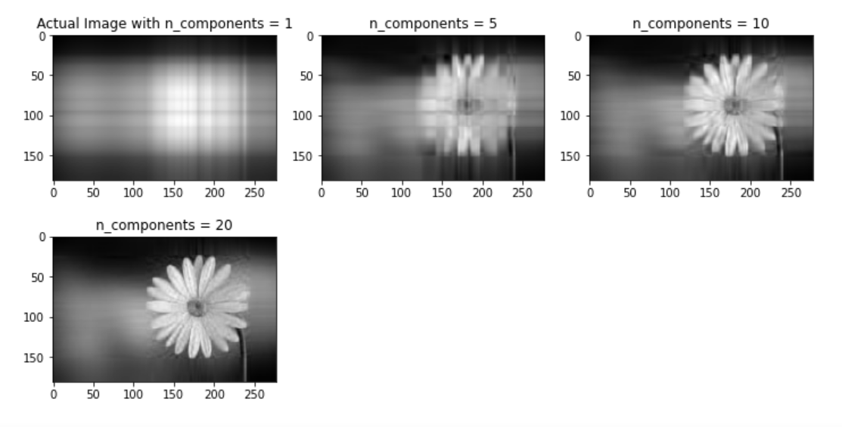

**RESULT:**

The above program was executed successfully.